SEMESTER 1, 2021/2022

CSCI 3301 CAAL Section 03

COMPUTER ARCHITECTURE AND ASSEMBLY LANGUAGE

 LECTURER: Dr. HAFIZAH BINTI MANSOR

**Assignment 3**

**PREPARED BY:**

|  |  |
| --- | --- |
| **NAME** | **MATRIC NO.** |
| MOHAMED MOUBARAK MOHAMED MISBAHOU MKOUBOI | 1820705 |

1. Draw a memory hierarchy diagram.

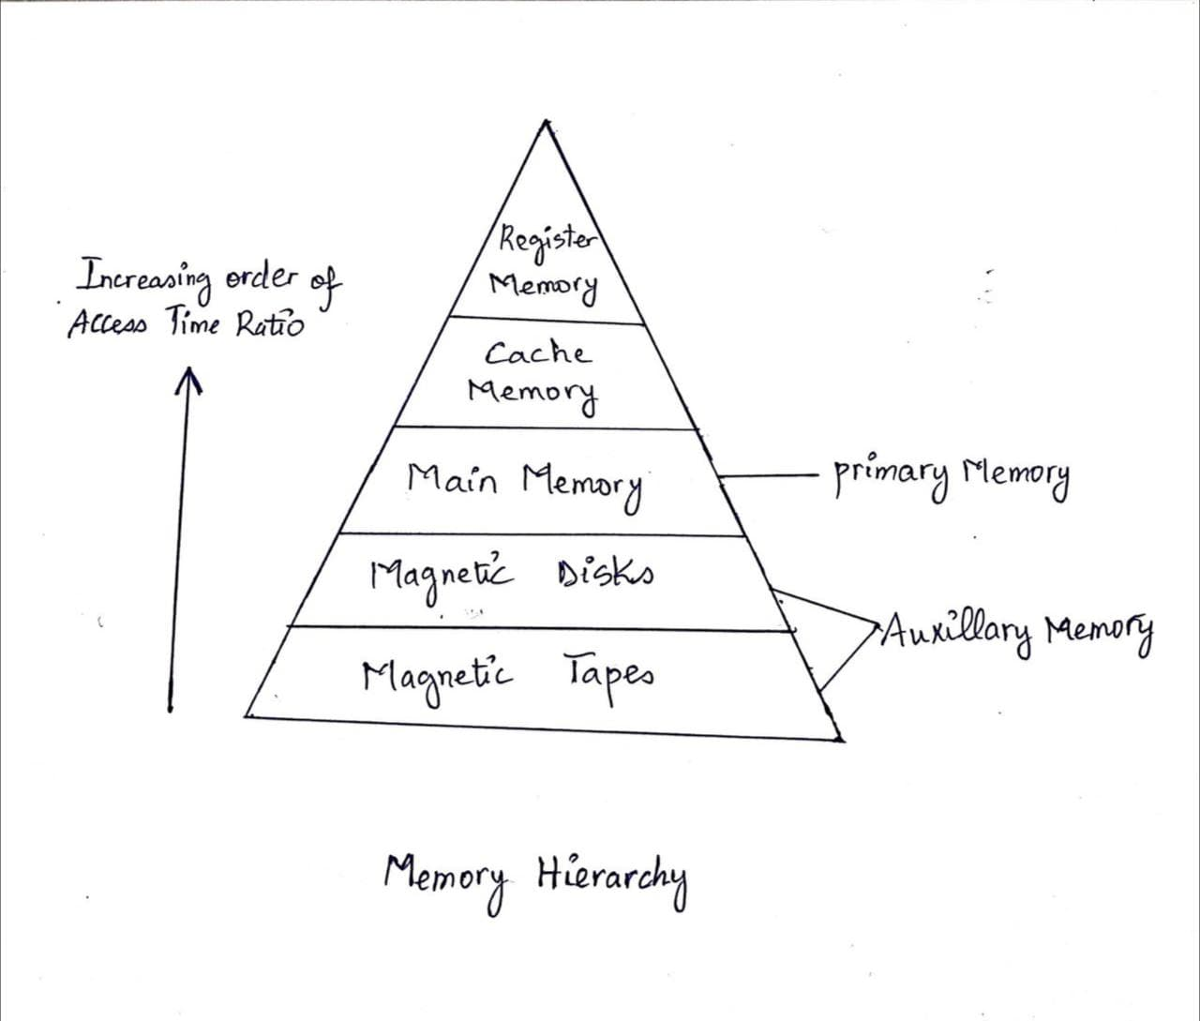

1. In a table, describe the different types of memory in the memory hierarchy in terms of performance, access time and cost.

|  |  |  |  |
| --- | --- | --- | --- |
| ***Type of Memory*** | ***Performance*** | ***Access time*** | ***Cost*** |
| Registers | A CPU register can store an instruction, storage address, or any other type of data. Registers are a sort of computer memory that is used to swiftly take, store, and transport data. They are also used to store data and instructions that are instantly needed by the CPU. | Cache memory is highly fast memory that is incorporated into the central processor unit of a computer. Cache memory stores data in temporary memory units rather than RAM, allowing data to be retrieved and saved more quickly. | Registers are quite costly since they must be extremely quick and accessible from several locations at the same time. |
| Cache Memory | Cache memory temporarily stores information, data, and programmes that the CPU often uses. When data is requested, the CPU will immediately switch to cache memory to provide quicker access. A cache hit occurs when data is found in cache memory - this is when it is accessed for the first time. | The best-case memory access time is tcache (ignoring cache controller overhead), whereas the worst-case memory access time is tmain. Given that tmain is normally 50 to 75 ns and tcache is only a few nanoseconds, the difference between worst-case and best-case memory latency is significant. | The faster a computer operates, the more cache memory it has. Cache memory, on the other hand, is more expensive to manufacture than RAM due to its high-speed capabilities. As a result, cache memory is often relatively modest in size. |
| Main Memory | When programmes and data become active, they are transferred from secondary memory to main memory. RAM is an abbreviation for Random Access Memory. | Fast RAM chips have access times of less than 10 nanoseconds (ns). The time it takes to get the first data character after making a request is referred to as disc access time. | Primary memory in a computer is pricey and comes in a restricted size. Secondary memory is less expensive than primary memory. |
| Magnetic Disks | A magnetic disc is made up of a spinning magnetic surface and a mechanical arm that travels over it. The platter continues to spin at great speed as the arm's head glides across its surface. A magnetic disk's data is read and written via a magnetization process. | Disc access times are the average of seek time and latency for hard and solid state drives. While rapid hard disc access times can be in the 5 to 10 millisecond range, solid state drive (SSD) access times often in the 25 to 100 microsecond region. | Magnetic tape technology now offers the lowest raw storage capacity purchasing price of $0.02 per GB. HDDs are available for as little as $0.033 per GB. |
| Magnetic Tape | Magnetic tape recording works by transforming electrical audio impulses into magnetic energy. The energy is imprinted onto a moving magnetic particle-covered tape. These pulses align the small magnetic particles into patterns as the tape goes past, providing a record of the sound. | The vast length of the tape housed in a cartridge, which is often hundreds of meters, leads in average data-access times of 50 to 60 seconds, compared to hard drives' 5 to 10 milliseconds. | Magnetic tape technology now offers the lowest raw storage capacity purchasing price. HDDs are available for as little as $0.033 per GB. Flash memory raw capacity is presently 12.5 times that of tape and 7.5 TIMES that of HDDs. |